Understanding the Atavus Arcade Business Model

The current arcade model is an essential component of any entertainment facility. Usually marketed as the secondary attraction, arcade typically can generate up to 20-30% of total EBIDA. However, understanding the industry, past and present, will shape the business model used by the Atavus Group.

History of the Arcade Industry
To appreciate the history of the Arcade and the future of the industry requires an understanding of the origins of the equipment that facilitate the industry.

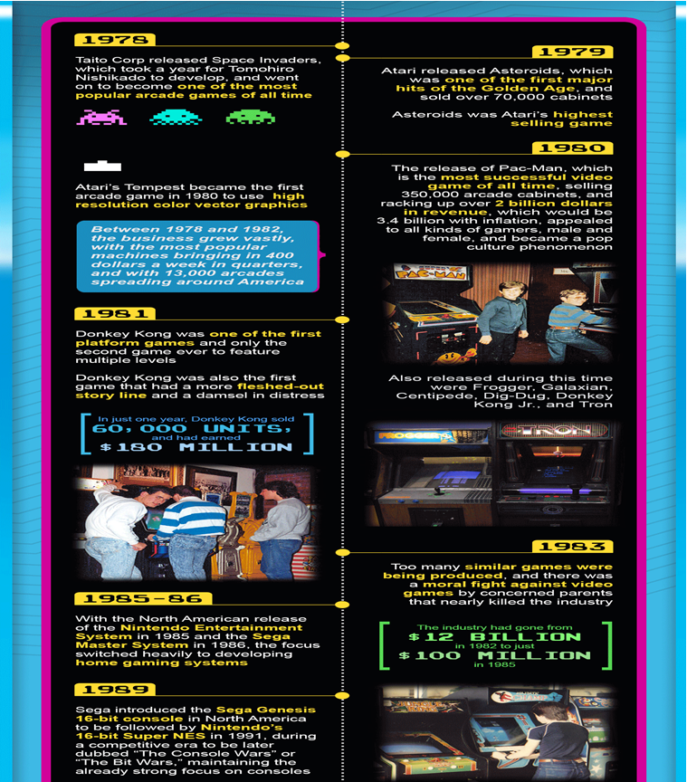
The 1990s are considered the apex of arcades. Inhabiting every mall and littering every street corner arcades became a part of pop culture.
However fast forward, a decade later arcades as a standalone business concept has faded.
Four main components forever changed the model:
- Arrival of cheaper home consoles with comparable or better graphics than very expensive arcade machines.
- Target Audience of arcade (13-18) are a very fickle group. This non-committal group shifted their focus to the next great fad in droves.
- Socially arcades became synonymous with youth rebellion. Arcade owners did not police their audience which gather for cheap fun @ 25cents rates. Hence drugs and thugs became pervasive. After a while parents (the bankers) stopped giving kids money to go to the arcade. Instead they bought home consoles for ‘safe’ fun.
- The Arcade Mix (The types of arcade machines on the arcade floor) were predominantly videogames (90%). Arcade owners could not keep up with rising cost of new videogame machines. Hence these types of arcade machines would stay at locations too long (sometimes years) and patrons began to lose interest.

Evolution of the Arcade Business Model
Faced with the catastrophic collapse in the standalone arcade model, other members of the arcade community, specifically Family Entertainment Centers (F.E.Cs) started seeing the fallout. F.E.Cs met less negative press surrounding arcades but still had to deal with the emerging home console market.
With arcades now representing 30% to 40% of revenue, F.E.C. began massive changes to secure their revenue. After extensive R & D they realized that combining more of a prize element to their arcade had a profound effect. In more ways than predicted, F.E.C. began reversing the downward spiral into an upward growth. Termed ‘redemption games’, patrons would play more skill based games that yielded a certain amount of tickets that could be ‘redeemed’.
The key draw were prizes as an incentive to play. ‘Huge’ prize centers filled with popular items that kids & adults would yearn for.
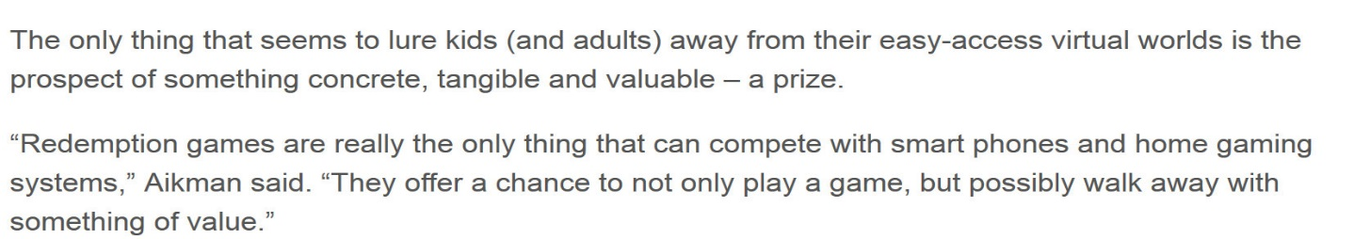

In fact the allure was so strong and so popular that studies showed that:
With this innovation the arcade industry in the late 2000s, took off again.

All major Family Entertainment Centers started adding or increasing their arcade divisions.

Bowling Centers


Skating Rinks


Laser Tag Centers

The new arcade model has gone from a phenomenon to an established commodity. In fact, to show that the power of the redemption philosophy in arcades, one only need to look across the waters to Florida.
A recent law change aimed at controlling internet café inadvertently banned prizes in arcades, there in killing redemption at Disney Resorts.

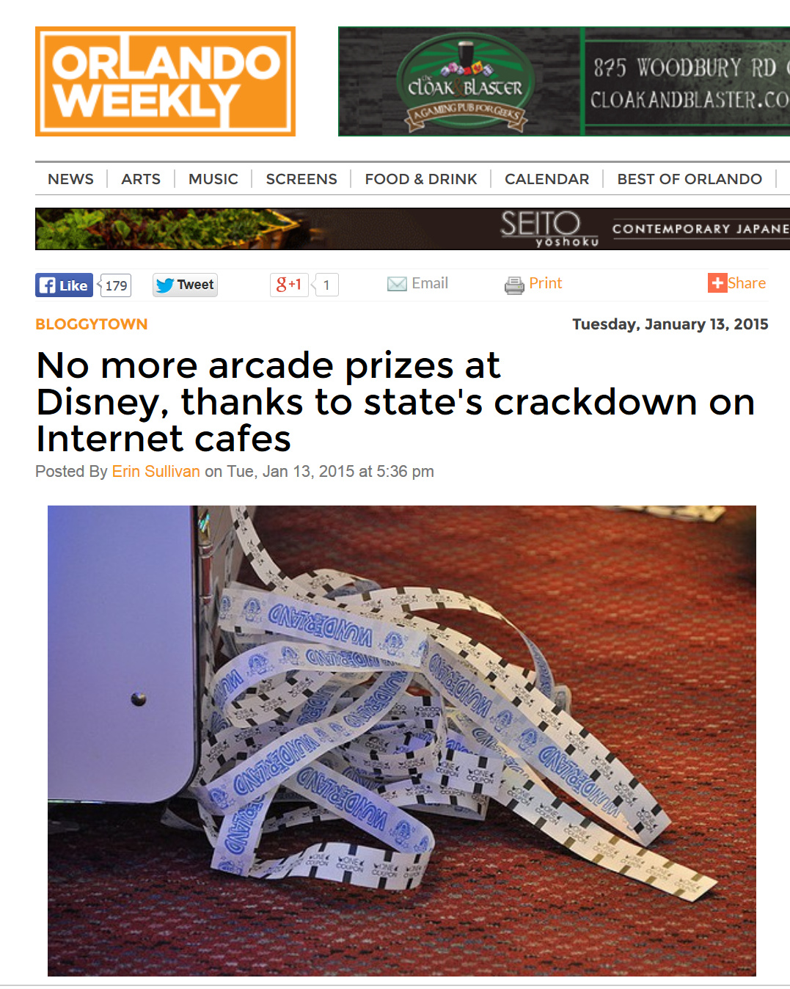

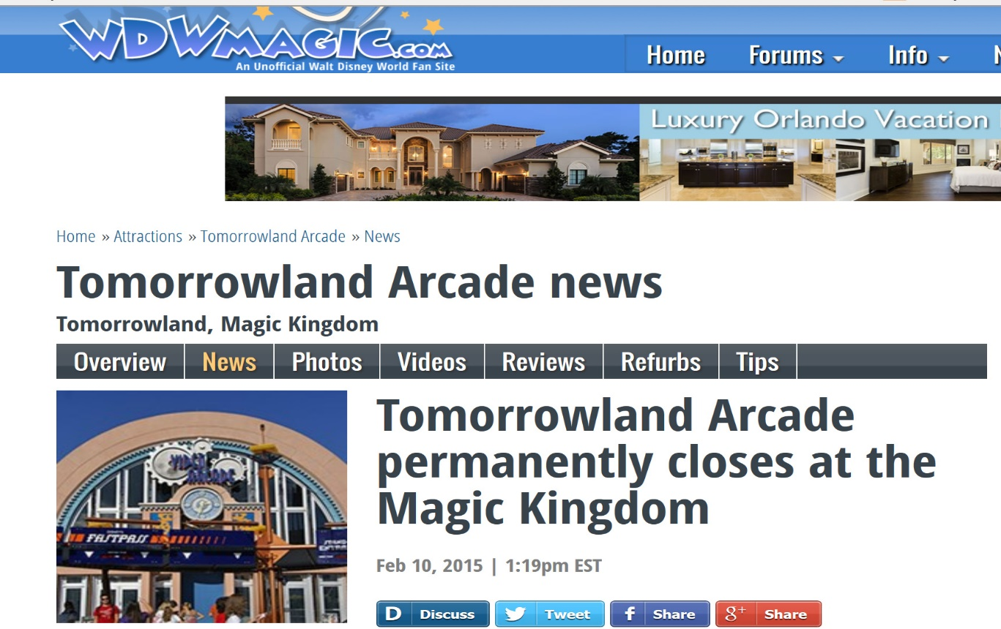
What was Disney’s reaction?

As profitable as the arcade division was, Disney understands that the arcade is useless without prizes.

New Arcade Mix
Besides drawing people back to arcades, redemption had three (3) other effects that greatly affected sustainability:
1. Decrease in Home Substitutability
Redemption games are so varied yet they incorporate more of a carnival/circus feeling. Games like Skee ball or basketball are games of skill. They are therefore inherently party oriented; thereby giving experiences that cannot be repeated at home. The equipment is too expensive for the average patron, so they flock to the local arcade.
2. A Change in the Focus Group
Videogames usually focus on action, violence and graphics; hence they usually only appeal to the teenage demographic.
As stated earlier, redemption games are games of skill that reward patrons with tickets that can be redeemed for prizes.
Hence arcade’s focus group moved from a narrow audience to a broader audience that also have cash flow.
3. A Decrease in Capital Investment year to year
Games of skill, i.e. Redemption games, take practice to get good at hence these types of games have a longer shelf life. For example Skee ball has a shelf like of 10 years once maintained.
Videogames shelf life are usually 24 to 30 months. Why? These games are less about skill and more about memorizing patterns. Videogames also emphasize graphics over playability.
When the patron has learned the pattern or has gotten bored of the graphics the video games’ revenue plummets.
- In the 90’s and early 2000s the arcade mix was 90% videogame and 10% games of skill with little to no redemption.
- Now the arcade mix is 70% redemption games, 10% videogames and 20% merchandize games with large prize centers.
From a capital perspective this is very important.
- Redemption games cost ($2k to $12k) with shelf life of 4-9 years.

- Videogames cost ($6k-$40k) with a shelf like of 24-30 months.

This means that for an arcade with 50 to 100 games, the switch to a redemption philosophy means that
1. Seventy percent (70%) of the industry will pay for itself within a year of its purchase versus ten percent (10%) in the 90s videogame laden arcade.
2. This also means that only a percentage of the ten percent (10%) of year inventory needs to be updated year to year.
Because of these reasons arcades are making a comeback.
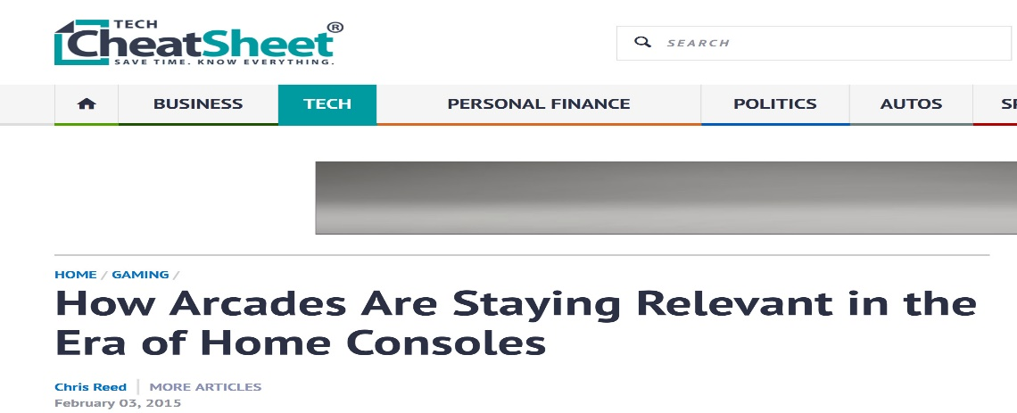
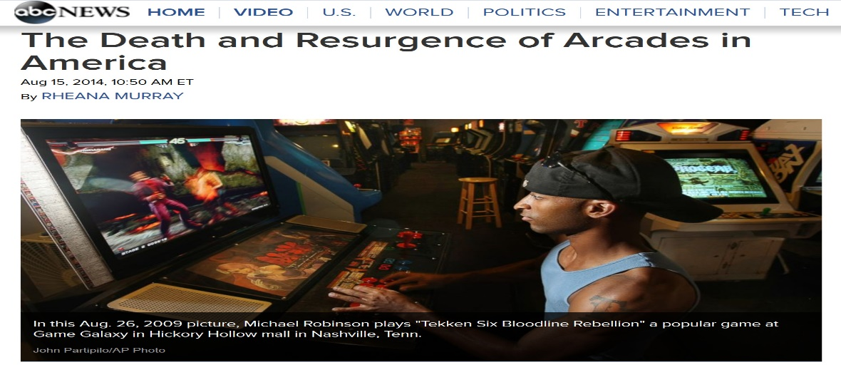
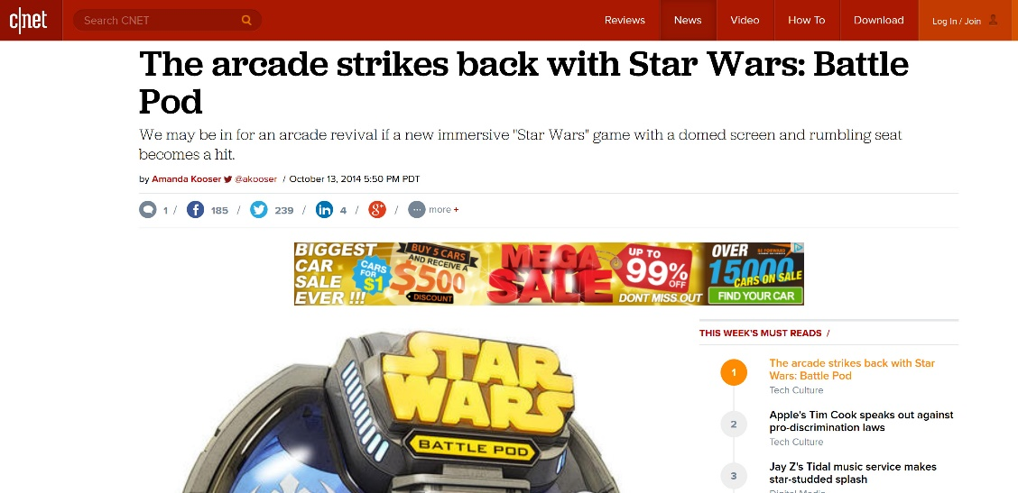

Now when theaters are built, an arcade is a foregone conclusion.
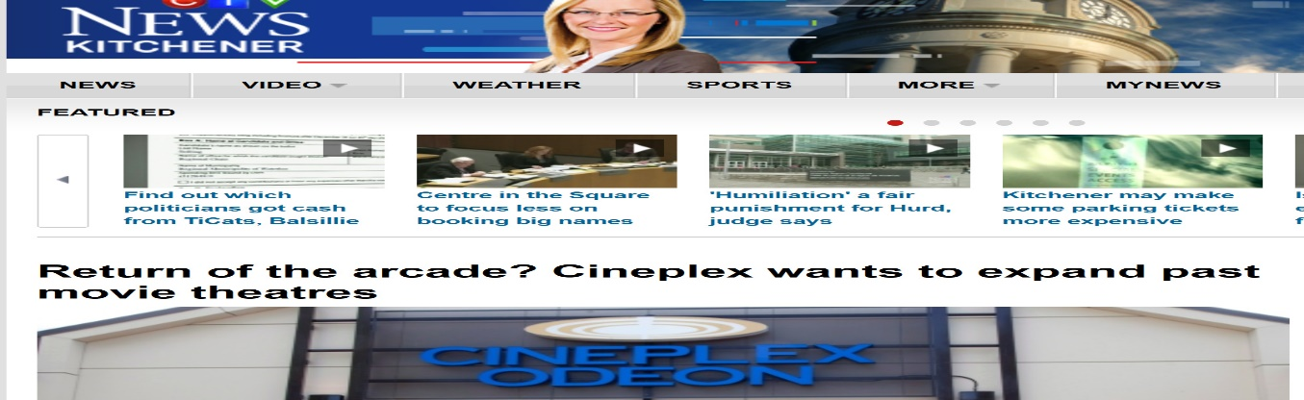
In Canada

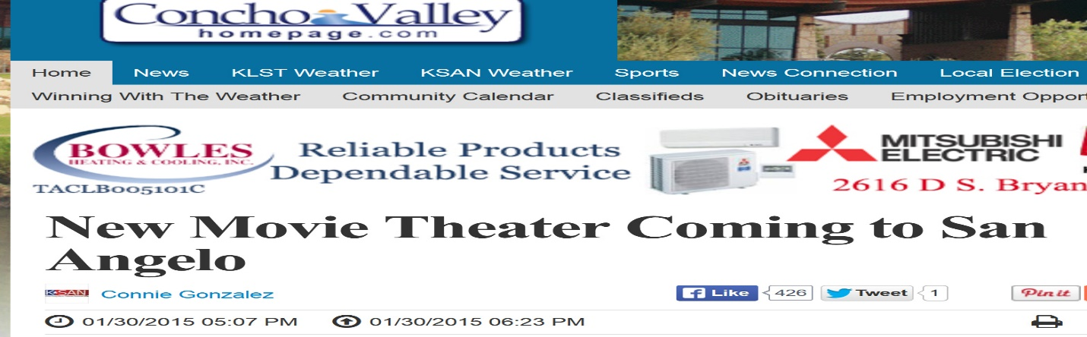
In The United States

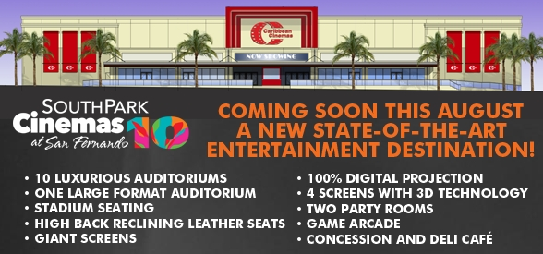
In The Caribbean
Competitive Analysis of the Bahamian Arcade Market
There are three major arcades currently operating in New Providence.
Atlantis Mario’s Bowling Mr. Pretzel
Arcade size sq. ft. | 3000 | 1800 | 2500
Party room | N/A | 1 | 1
Arcade Revenue | Over $1,000,000 (update 2015) | $500,000  (updated 2013) | 2007-2012  Average $450,000  (updated 2015)  $150,000
Party Rental Price | N/A | $250-$400 first 10 | $300-$399 first 10
Redemption Rate | N/A | Low (station not consistently stocked) | Low
Currency | Swipe card | Coins | coins
# of Arcade Machines | 53 | 60 | 31
Maintenance | N/A | Poor  (1) Only Certified Technician in Bahamas.  (2) Cost issue | Good, regular

For the sake of this exercise, Atlantis arcade will not be discussed because their customer focus is different. Hence this analysis will discuss the other members of the arcade community.

Mario’s Bowling Arcade
Strengths
1. Location
In Bowling Alley: Globally established relationship synergistic
2. Demographics
Strong teenagers
3. Size
Large space room to grow
4. Redemption center placed in correct position, at the front by entrance with large foot print
5. Big Party Rooms
6. Full service kitchen (for food and beverage choices)
7. Large amount of videogames
8. Arcade space owned by facility
Weaknesses
1. Staffing
No staff consistently dealing with customers’ issues (token stuck, ticket jams-maintenance cost)

2. Token based system (theft risk)
3. Redemption center is a mess
- No prize for months
- Recently added a few prizes
- No one consistently mans it
- Overall poor redemption execution
4. Wrong arcade mix
- Too much video games
- No kiddie rides
- Few family games (only air hockey)
- Not enough redemption games
- Too many not working
5. Too many outdated games over 4 years old
6. Poor cash position with lack of financial flexibility.
7. Five dollar ($5.00) entrance fee to play in arcade.

Mr. Pretzel
Strengths
1. Location
- In the Mall at Marathon
- Next to Galleria Cinemas (Their main customer base)

2. Proper staffing on the Floor
3. Proper maintenance with fewer than 2 machines out of 31 machines down
4. Kids as a customer focus hence strong kids (4-12yrs) following
5. Signature Pretzels and Drink provide food and beverage solution
6. Free admission
Weakness
- The business model is obsolete. Standalone arcades are dead!

2. Token system
- Increase theft risk which leads to decrease revenue when machine is down
- Maintenance cost leads to increase in customer frustration
3. Space
- Small space (less than 3500 sq. ft.)
- Leased space with increasing yearly overhead expense
- Limited chance to expand because needed positioning next to main drawn (Galleria Cinemas)
4. Limited Customer Base
- Focused on kids crowd with no attention to parents
5. Financial Hardships
- Dwindling profits because of flawed business model and lack of growth potential
6. Poor arcade mix
- Too many kid’s games
- Not enough teen or adult games-no shooters and one racer
- No family games (air hockey)
- Too many underutilized redemption games
7. Redemption Center
- In wrong location-back of arcade
- Small Foot print
- Not stocked properly
- Poor prize selection
- Center not consistently manned
- Prizes offer poor value for the money spent

8. Food and Beverage model which represents over 30% of revenue being eroded on two fronts.
- Located next to the food court of the Mall
- A logistically stronger substitute product (Auntie Annie’s’) is eroding profits on the product with the highest margin (pretzel) COGS= .30 sale=$3.00

Atavus Arcade Strategy

Arcade Vision:
Provide an enjoyable experience that cannot be replicated at home or duplicated by the competition.

The Atavus arcade strategy is predicated around the competitive advantage erected by
1. The Arcade currency
2. The Redemption Center
3. The Arcade Mix

The Arcade Currency System
There are two components when considering the arcade currency.
1. Tickets vs e-tickets
2. Tokens vs swipe card systems

I. Tickets vs E-tickets
Though E-tickets are the wave of the future, physical tickets have been shown to drive sales for obvious reasons. An e-tickets’ winnings’ are issued to the swipe card, hence the player only mentally recognizes that they have won. For adult players, that’s not as big of an issue. For kids, it’s another matter. Kids (and adults) love to see the tickets fly out of the machine when they win. This psychological reward also drives others to play as they also see the ticket payouts.
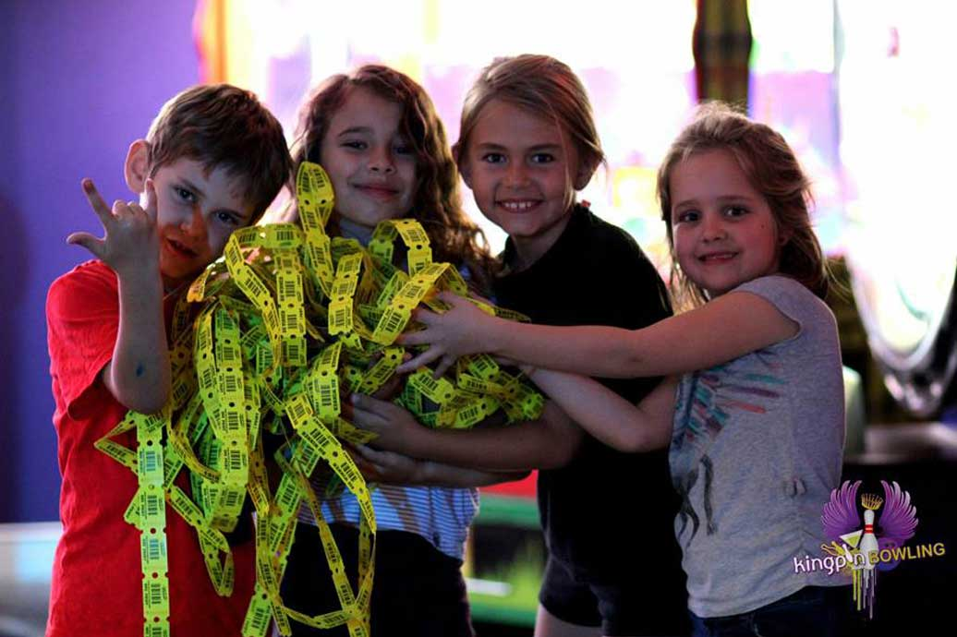
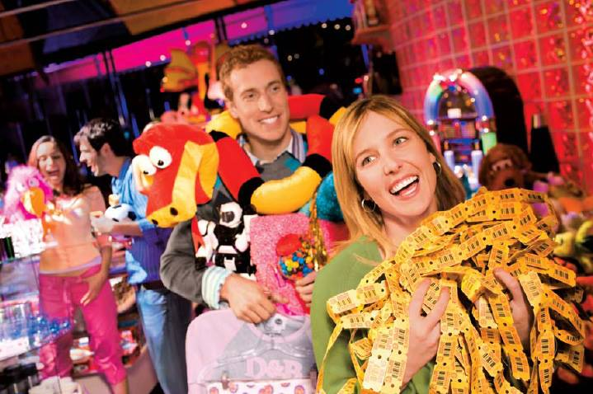
Physical tickets have their problems:
- Ticket jams
- Theft risk
- Shipping cost

Hence over the next two years they will be phased out. Every Tuesday will be ‘Ticketless Tuesday’. This will be offset by reduced prices on games as an incentive.

II. Tokens vs Swipe Card Systems
Tokens are part of the Bahamian arcade experience. However, this hard currency will not be used in the Showcase with IMAX arcade.
Why?
1. Maintenance
Tokens have a mesmerizing effect on kids and adults alike. They hold onto them tightly as they walk around the arcade looking for games to play. This simple act changes the magnetization of the coins hence causing machine jams. Besides the obvious loss of revenue due to machine down time, customer satisfaction also tanks. Token jams are the #1 issue of arcades.
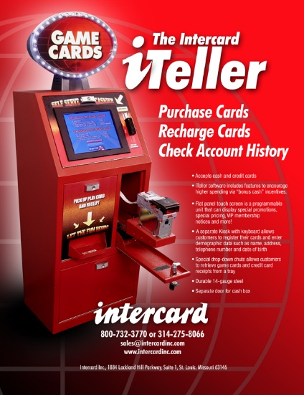
Swipe Cards obviously eliminates this issue. Swipe card is a Debit card system. Patron can add money to their permanent loyalty cards or buy disposable cards from dispensers.

Furthermore, the technology has progressed to the point that the cards are no longer swiped. This is important because that was the #1 issue with swipe systems. Simply tapping the card reader initiated the process. A second tap allow the machine to acknowledge that the customer wants to play.
Also imperative to operations is the fact that this swipe card system is Wi-Fi-based. Also noteworthy is the point that individual games continue to work even when the main server goes down.(#2 issues with card systems)

2. Security
Token theft is the #2 major issue for arcades. How?
a. Customer-based issues:
- Customers try to break into the machines to steal tokens. This leads to machine abuse and damage.
- Customers bring tokens from other arcades or even quarters that jam the machines.
b. Employee-based issues:
- Token theft is the single biggest reason for arcade employee termination
- Employees set up black markets with friends for these coins for free plays

Obviously Swipe Cards eliminate all of these issues. They also bring in two (2) major effects.
- Increased spending by almost 30% over token based systems.
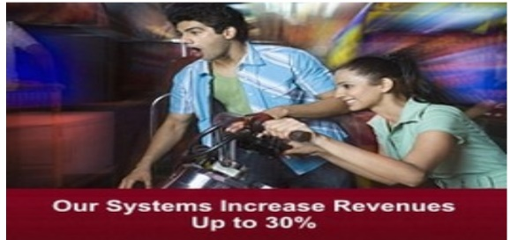


Why?

‘The credit card effect’

Cash, in this case, tokens are a tangible thing. When you spend it, you see it leave you hand. You process the loss immediately. Swipe cards are on the other end of the spectrum. Psychologically, it’s harder for adults to process the loss of funds. Now translate that mind set in a child and magnify the effect. Kids spend more at arcades when given a card.
Even when the cost is realized arcade customers still recharge their cards and keep playing at a higher rate than with tokens.
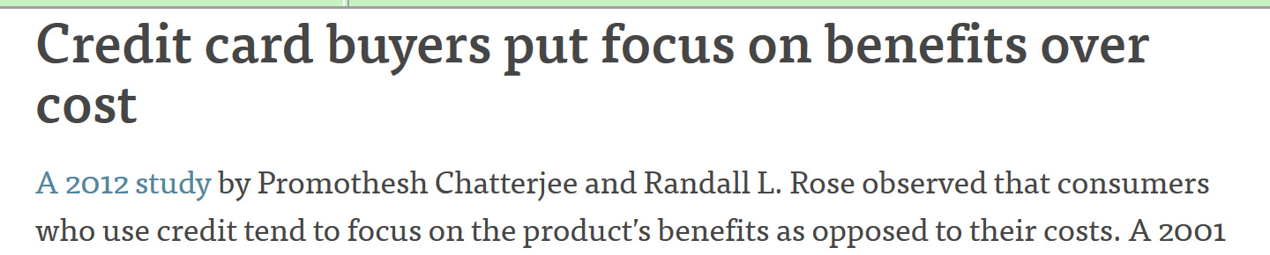
Why?

This is why the arcades’ redemption center must be fully stocked at ALL TIMES. Without the benefit, customers now only consider the cost. Hence the arcade machine itself must please the customer more versus the machine with the prize to incentivize.

2. Swipe Cards Increased Data Tracking:
A. Monitoring the Machines
From checking the diagnostic machine reports to alerts on possible machine payouts, tracking is key. This allow management to see whether machines are performing and what needs to be adjusted. This also allows better accounting practices because management can gauge win percentages and adjust per machine. This has never been done in Bahamian arcades and is vital to fiscal responsibility. Being able to adjust hit ratios per machine (and when machines payout) determines operational viability.

B. Monitoring the Customers
Knowing what each particular customer wants and their rate of play is a key feature of the swipe card system. This determines future machine purchases as well as present day charges. This also allows management the necessary data to offer personal promotions.

C. On-Demand Reporting
A daily report is generated for the entire arcade.

D. Increase Operational Flexibility
With tokens, the prices is the price. There is no getting around this for customers. Either a game is $1.00 or it’s not. With swipe systems, a whole new world is open to operators.
A. Flex Pricing: No longer are operators stuck with currency values of 25cents increments. Management can now be more accurate with pricing: 37cents or 43cents for a game. This allows for more psychological pricing. E.g. having a 95cents game vs. $1 game.
B. Chronological Pricing: Time of day or day of the week pricing is now an option. This allows for strategies to attack slow days to boost sales or ‘Happy Hour’ pricing.
C. Specialized Pricing: Whether it is part of a VIP package or a birthday promoting, swipe card allow individual pricing without affecting the general public.
For example, a party can now buy time slots of gaming. Party participants play for free with their cards, while regular patrons use the same machines and pay normally.
This was one of the problems Mr. Pretzel had. If a large party wanted to buy large slots of time in the arcade, a large amount of tokens had to be removed from general circulation. This interfered with the amount of tokens normal patrons would get. Hence Mr. Pretzel had a policy that no party could buy the entire arcade thus preventing the locking out of normal customer. Swipe cards solve that issue.

Redemption Center

Understanding the mind of the customer is imperative to yielding the appropriate redemption center experience. When the average person walks into a properly structured arcade, they are forced to walk past the fully stocked redemption center. It is here where the desires of the player is shaped.
Studies have shown that individuals will identify items they want to play for. Patrons then find a game they loved that yields the most tickets in the pursuit of “The elusive prize.” This is the power of redemption in arcades today. The quest for the prize has supplanted the games themselves as the #1 reason patrons return to their favorite arcades.

The Goal of Redemption
With this understanding of the mind of the player, redemption centers’ goals are simplified:
(A) Eye on the Prize
Inspire players to play more for the perceived value (reward) they believe can be attained.
(B) Saving the Best for Last
The better the prizes in the center, the more people hold onto their tickets. Hence they can accumulate, allowing the redemption center to keep restocking cost down.


How is this accomplished?

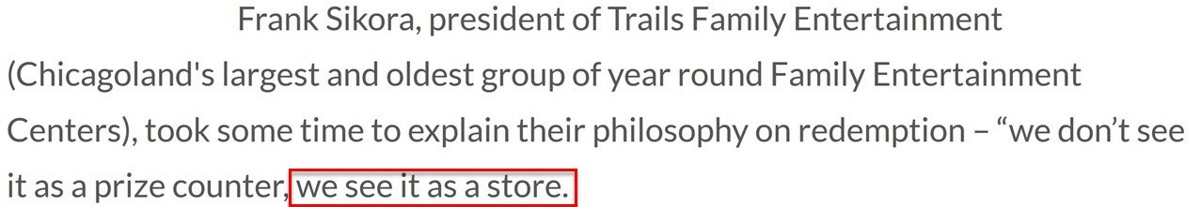
In an article about winning redemption centers, the 2013-2014 winner of the Top Global Redemption Center spoke about the right philosophy:
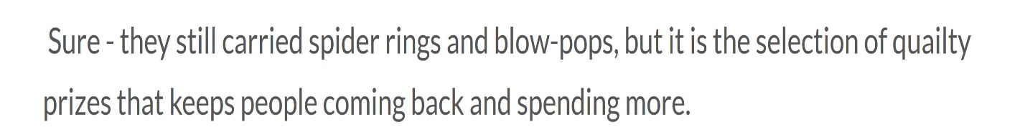

This premise has been echoed throughout the arcade industry for the last decade.
If you treat you redemption center like a store then:
- Tickets are your currency
- Prizes are your commodity.
Finally and most importantly;
- Your customers are smart shoppers looking for value for their money.

Hence you are not competing with other arcades, you are competing with toy stores and candy stores to provide that value. This fundamental principle allows an arcade owner to stock redemption centers according to the desires of the customer base.
The prizes must be worth playing for.

Lesson: Current Bahamian Redemption Center Errors
Quick Reminder:
Successful Global Arcade Mix formula:
- 70% Redemption Machines
- 10% Merchandisers
- 10%.Videogames Machines
- 10% Novelty Machines

Mr. Pretzel had more redemption machines than Mario’s bowling arcade (90% to 40%). Theoretically Mr. Pretzel should be more profitable.
Why?
Mr. Pretzels’ arcade mix is closer to the preferred formula. However this argument is made mute by another factor:
None of them actually have anything to redeem.

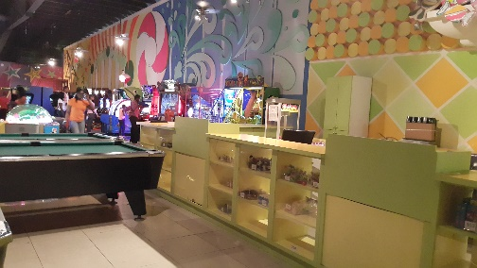
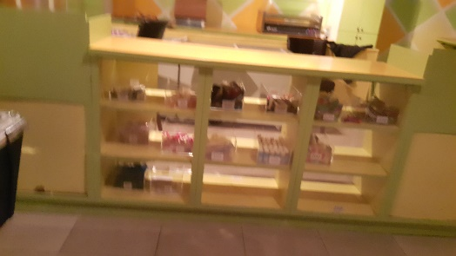
Mario’s bowling:
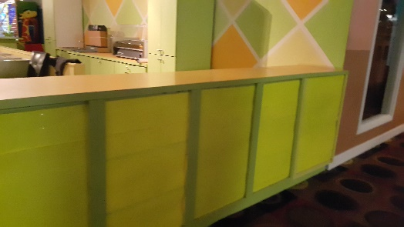
Analysis:
This is completely opposite to their own business model. Notice the empty shelves and the complete lack of prizes for adults (candy only) in a facility that caters to the same. This is an anti-redemption approach.

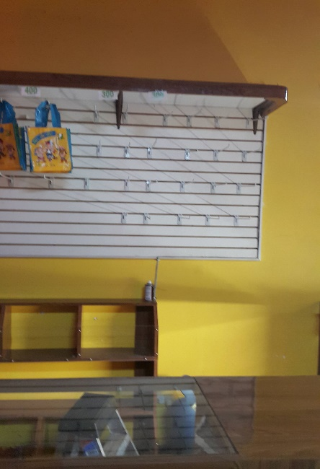
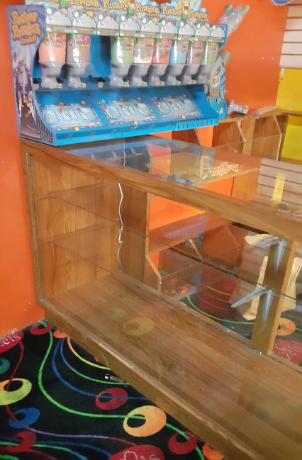
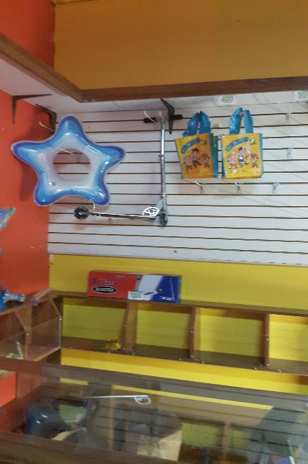
Mr. Pretzel

Analysis:
Notice the empty shelves that tell the customers what their real value is to the company. Notice the lack of personnel manning the counter. There is no incentive to customers to frequent the facility. The little Mr. Pretzel does offer is inappropriately priced.
This complete lack of respect for the customers’ value and intelligence is exemplified in the following:

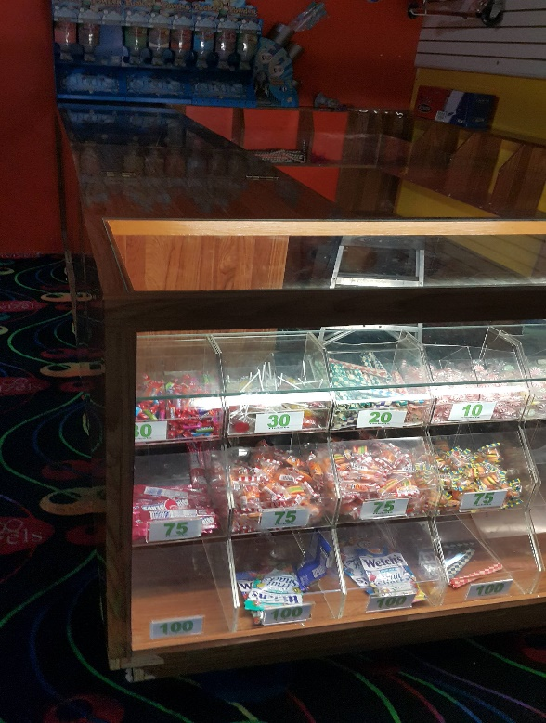

Candy at 75 ticket
(Street value: 45 cents Ticket value: $34)

Fruit snacks at 100 tickets
(Street value: 75 cents Ticket Value: $41)

This type of price gauging only leads to customer disloyalty.

These inadequate redemption centers with little to no prizes eliminates the selling points of issuing tickets. This therefore renders both redemption rates to zero.
.
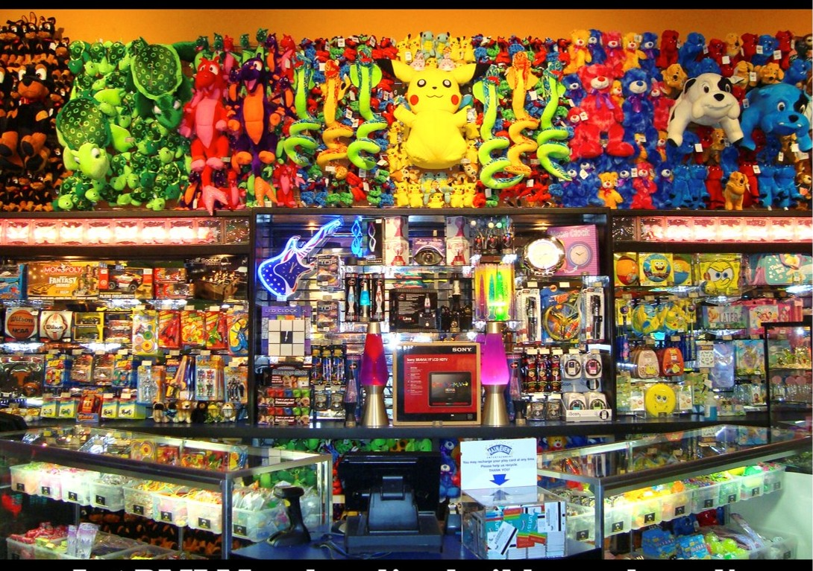
This is the stocking strategy of the Showcase Redemption Center as stocked by BMI Merchandising:
Note the branding and theme based merchandising. The value given to customers will also be reflected in the low ticket counts needed to win. Hence win-ability is a driving factor in driving arcade revenue.

B. Stocking the Redemption Center
As stated earlier, Bahamians are much atoned with American Pop culture. Hence stocking the redemption center should reflect the same. Besides the obvious candy and regular plush toys, prizes must match the desires of the customer.
This is where the Showcase with IMAX has a true advantage versus existing and future competitors.
Because movies are such a huge part of the Bahamian entertainment experience, having movies specific prizes will drive sales.
This redemption phenomenon is prevalent in movie chain arcades like Cineplex in Canada. The added advantage is as follows; when promotions for movies are over, studios have ample promotional stock they no longer need. Theaters can purchase these items for pennies on the dollar through existing relationships. This allows the Showcase to keep cost down while passing the saving on to the customers in the form of reasonably priced merchandise. This provides another defining element that encourages the consumer name brand loyalty.

C. Controlling the Redemption Center
As stated earlier, the redemption center will be operated like a retail store. With this in mind, the constraints of the same must be applied to control cost, theft and maintain accountability.
From a technical stand point, a two prong approach has been deployed.
- An At-The-Counter Strategy
- Restocking Strategy

1. At-The-Counter-Strategy
The At-The-Counter experience is key for great customer relations. However, it is also the beginning of the financial component of the redemption experience.

Intercard has been chosen to provide the redemption solution. When customers bring their tickets to be redeemed, the transaction starts with:
(a) Scanning of their card to check the customer balance
(b) Redemption points are shown to customer
(c) Patrons selects item
(d) Item is scanned out of inventory as customer receives prize.

2. Restocking Strategy
As items are scanned out of inventory a stock deficit accumulates. This is a critical issue that has plagued the arcade industry of the Bahamas. The previous solutions were:
- Overstock popular items (theft concern/monetary issues)

- Replace items in mass as redemption counters wither (customers stop playing without their prize incentives).

Atavus has employed a revolutionary technology; Automated Restocking System (ARS) by BMI Merchandising. BMI is an industry leader that supplies giants like Dave & Busters and Disney World. BMI’s ARS software solution is the only one in the redemption industry.
ARS will provide:
1. Weekly Inventory Analysis
2. Biweekly shipment for just-in-time stocking
3. New item introduced for approval with suggested pricing/barcode and ‘where to display in center
4. Instant Scan Book
- The Entire store contents with points value and barcodes
Effect:
- Reduced facility personnel’s time/labor cost
- Reduce theft of products because items are pre-tagged
- Reduce inventory cost by preventing overstocking
Note: Atavus and BMI have started website to track stock orders and deliveries in real time.
5. Weigh to Count
-for small point items like candy
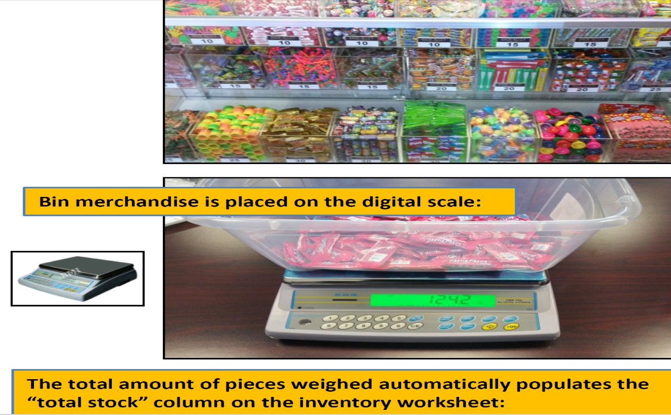
Benefits
- Time saved
- Accuracy as weight is converted to a count value for inventory purposes.

Atavus Arcade Mix

Understanding the proper arcade mix is essential to profitability. Again, the Arcade Mix refers to the types of arcade machines that populate the game room floor. Whether you have more redemption vs videogame or novelty machines will determine profitability hence viability.
Arcade Philosophy
The key ingredients of the arcade mix are built on:
1. Flexibility
2. Interactivity
3. Positional Strategy
4. Proper Maintenance
5. Marketability

1. Flexibility
This speaks to the need for an arcade to remain fresh. Hence from the arcades’ inception this must be considered from a structural and purchasing standpoint.
Structurally:
The parents’ need to have a line of sight on all their kids is fundamental. Spacing between machines therefore directly relates to parental return ratios. Spacing is also important for redemption maximization. For example: The closer the return redemption machines are to the redemption center the higher profitability is for the arcade. Why? People like looking at what they can win when they play.
Purchasing:
An emphasis has been placed on buying games that allow monthly to annual updates of software.
Why?
These updates bring new stages and characters for customers to experience. Hence an increase in the playability and the life span of equipment occurs.
Updates also bring global leader board date. Leader board date has been shown to drive play ratios as players are engaged in a new challenge.

2. Interactivity
Human beings are social creatures by nature. Therefore, allowing entire families to interact at the same time in a safe environment is key.
Interactivity is important to differentiate the facility from the home where individuality roles, mobile and internet have isolated the family.
Having arcade games that require skills while stimulating group involvement has been shown to generate higher profitability.

3. Positional Strategy
Maximizing profitability through a positional strategy is key. Getting the most value out of the arcade starts with recognizing how many positions at each machine is available,
Hence it stands to reason that the more positions (the place where the customer plays on the arcade machine), the more profits are possible. Therefore buying a machine with multiple positions:
A. saves space
B. increase comradery

4. Proper Maintenance
Nothing frustrates a customer more than a malfunctioning machine that steals their winnings. This leads to staff abuse. Ultimately lack of maintenance leads to decrease profitability. Hence buying machines from established companies and stocking spare parts is key.

5. Marketability
Marketing the arcade through brand reorganization and playability is fundamental.
Buying machines with pop culture ties has been directly tied to profitability. This also allows a better reference point for advertising.

The Concept of Critical Mass and the right Arcade Mix
Playability references the amount of perceived value derived from an arcade machine. Some customers like fast action, quick play. Others prefer games with more longevity. The perceived value is very subjective hence the need for a diverse arcade mix. Therefore to properly accommodate the right arcade mix requires a minimum foot print. In turn, the same will resonate with a larger customer base.
Hence to properly serve the market with an appropriate arcade mix in a minimum sized foot is called Arcade Critical Mass. Arcade Critical Mass for an FEC serving a customer base greater than 500,000 patrons with an attachment rate of 15% or greater:
57 Machines or greater in 3000 sq. ft. or greater

Lesson: Local mistakes in Critical Mass coupled with Wrong Arcade Mix

Case Study: Mr. Pretzel’s Critical Mass Dilemma

Subject: Mr. Pretzel in the Mall of Marathon
Business Model: Food and Beverage with arcade and party components
Target Market: Exclusively kids
Problems:
Arcade configuration predisposed the parents of the target audience (kids) to just stand there and watch or sit out in the mall’s food court. Hence the money (the parent) was leaving the building.
Why?
Because of space issues there was only one single adult videogame in the entire store: a bike game.

Net Effect of Business Model
1. Adults felt disenfranchised
2. Only kids felt welcomed

Residual Effect of the Arcade Mix on rest of the Business Model
Industry-wise Mr. Pretzel’s business model should yield party revenue of 30- 40%. Party revenue was below 20% and dropping fast.
Why?
- Parent/Adults are the individuals that booked parties not kids
- Whether its birthday parties or corporate events, adults must feel comfortable before booking.

Trying to fix the problem:
- Management recognized the effects of the problem but not the source.
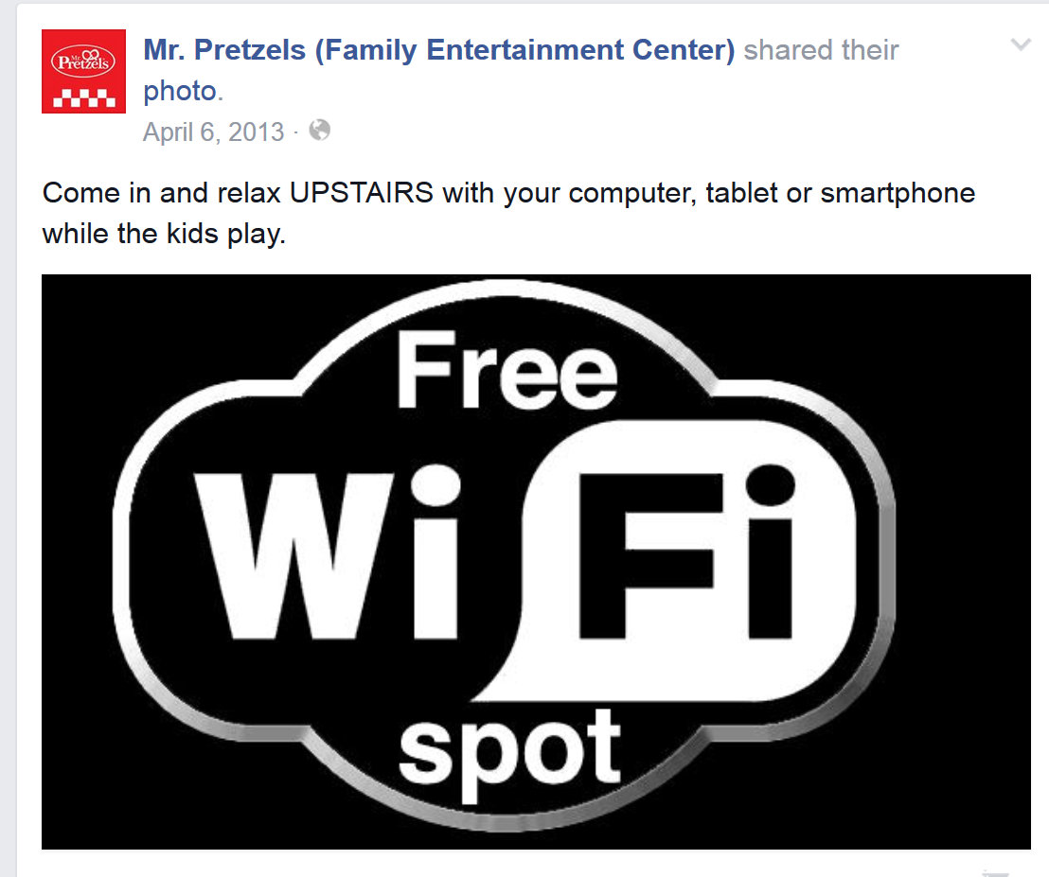

Parents, after years of being pushed outside, never responded.
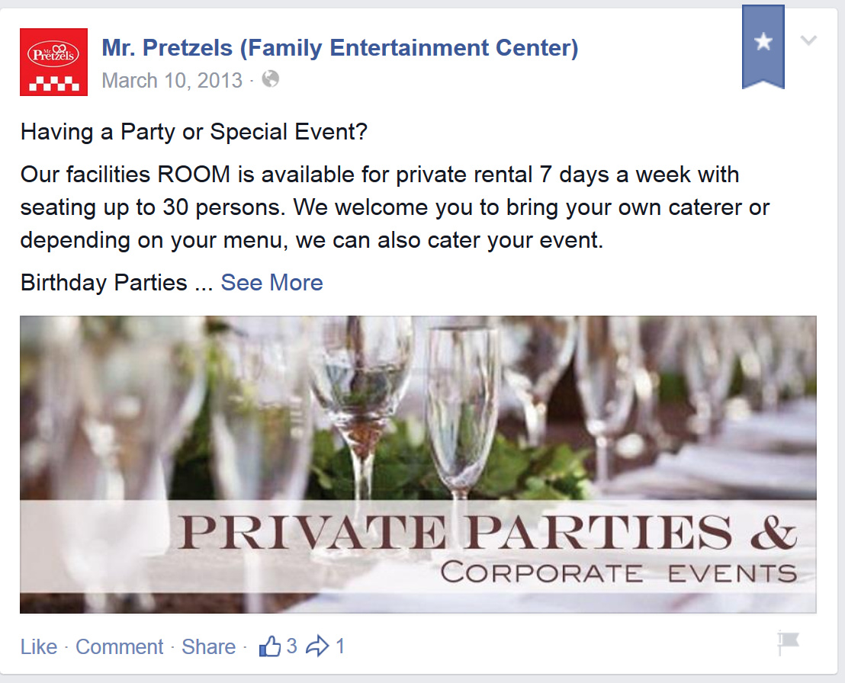
- Management tried to diversify their party/customer clientele

But to no avail. Why would adults now frequent a perceived kid’s center?
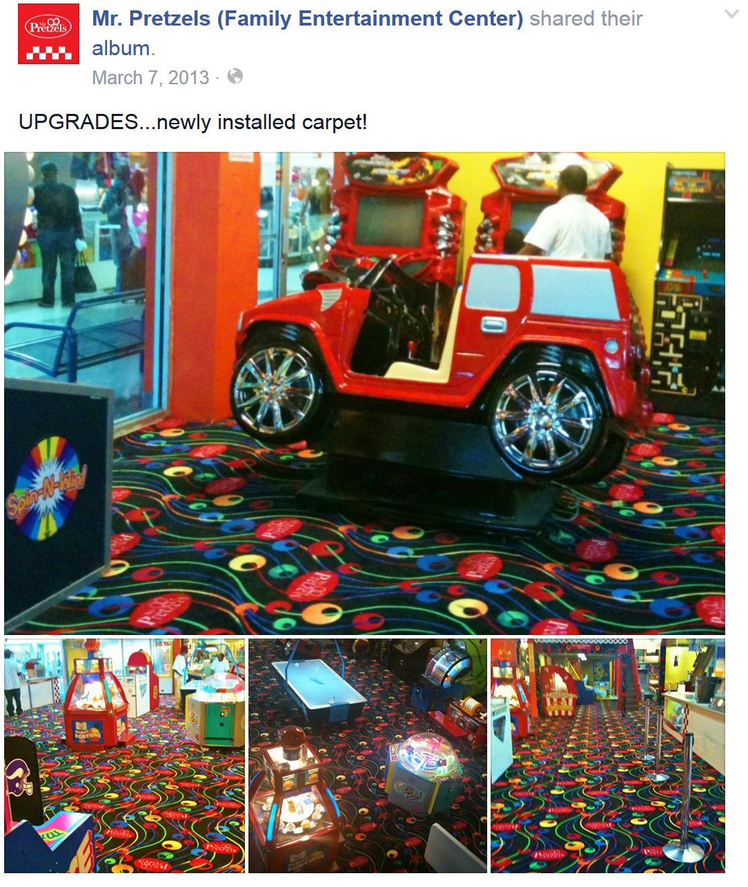
- Management tried to throw money at the problem

This is what Management called an upgrade; not new Machines or a better Redemption Center.
Note: Properly outfitting the redemption center would have actually been cheaper than all new carpet

- Management finally recognized that they needed professional help to sell the party rooms

This too did not work. You need a product to sell.
Frustrated with the business, the original owner sold the business in March 2014.
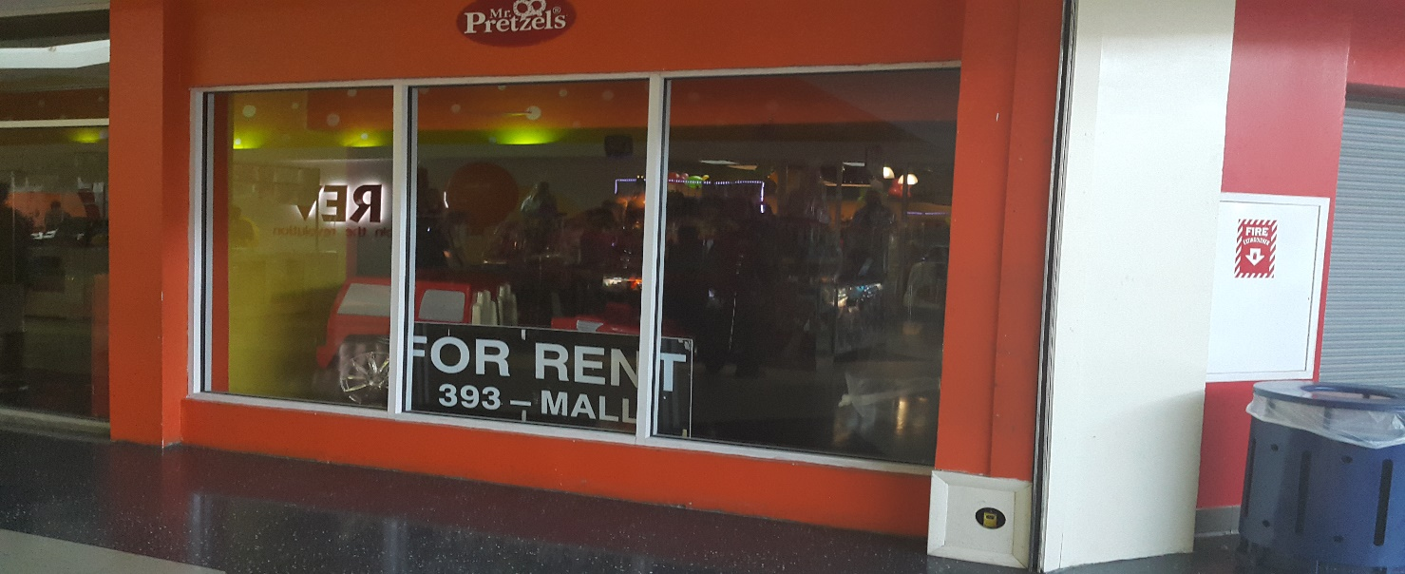
On the exact anniversary of the sale one year later……..

OUT OF BUSINESS……ENOUGH SAID
The Atavus Arcade Mix

A company’s’ arcade mix should reflect the target group bias. However the same should also recognize possible income from minor sources. In the case of the Atavus Arcade Mix, the main target audience is between 4-17yrs for 60% of the business.
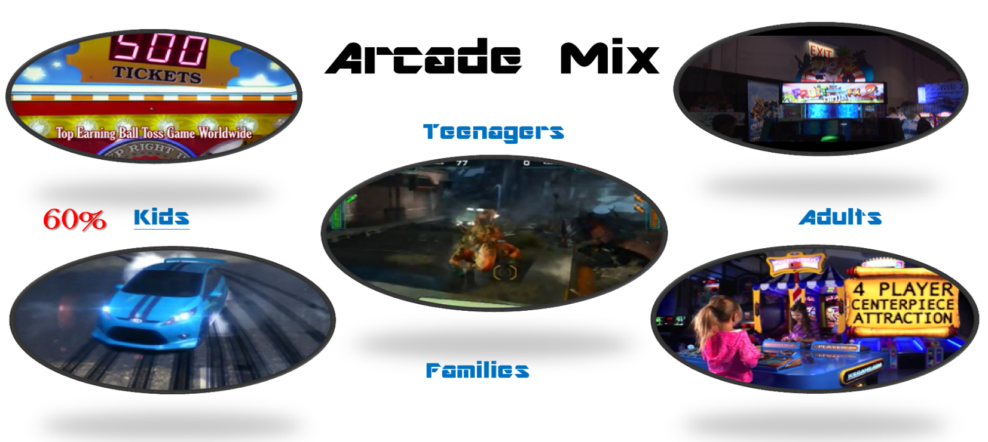
Learning from the mistake of others, the arcade will cater to the following:
- Main Target Group (60%): Kids Age 4-17
- Secondary Target Groups:
- Teenagers (10%)
- Adults (20%)
- Families (10%)
To facilitate the best approach to serve each group proportionally while showing the proper respect to all the following will be instituted. A game segmentation strategy will be applied to each target group. This will entail centering activities for each segment around main attractions. The attraction will drive foot traffic to each area as patrons wait for their turn. A spillover effect will then ensue as less desirable machines in that segment are used until the main attraction is free.
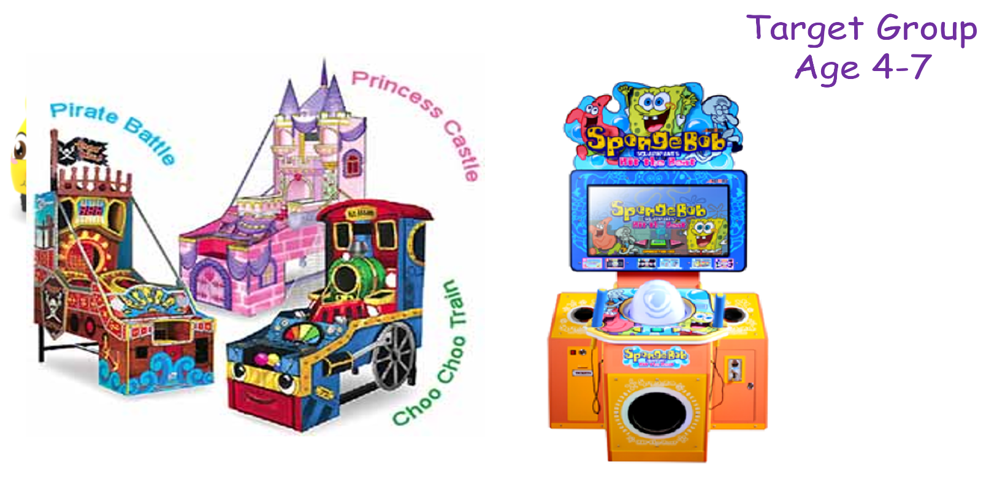
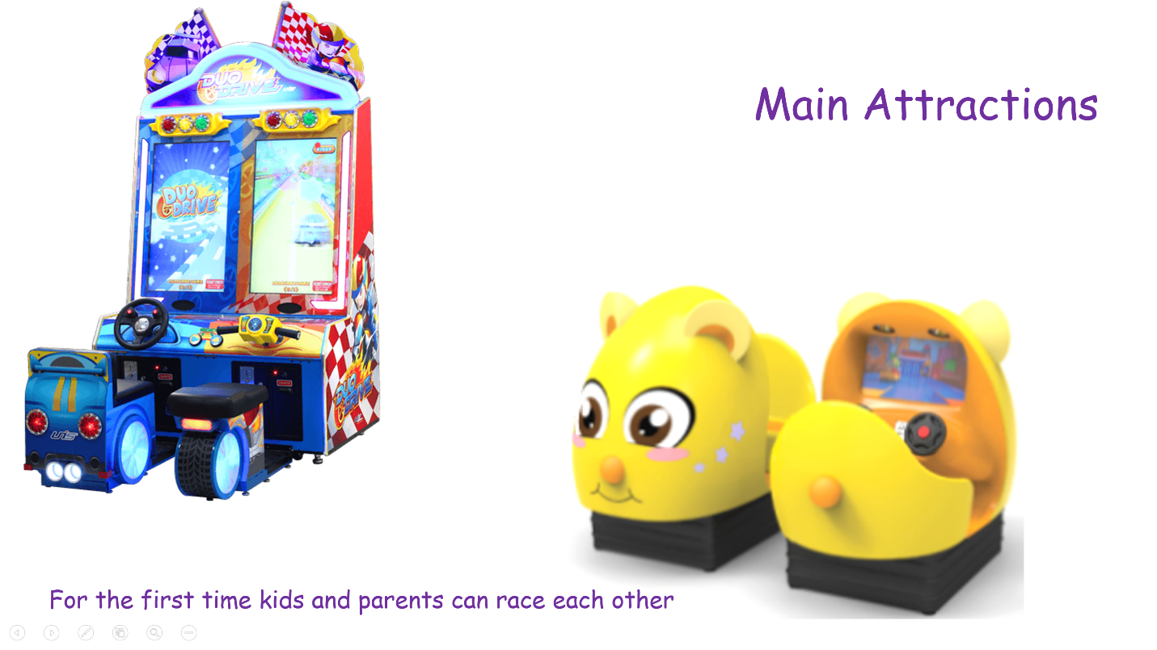
Game Segmentation
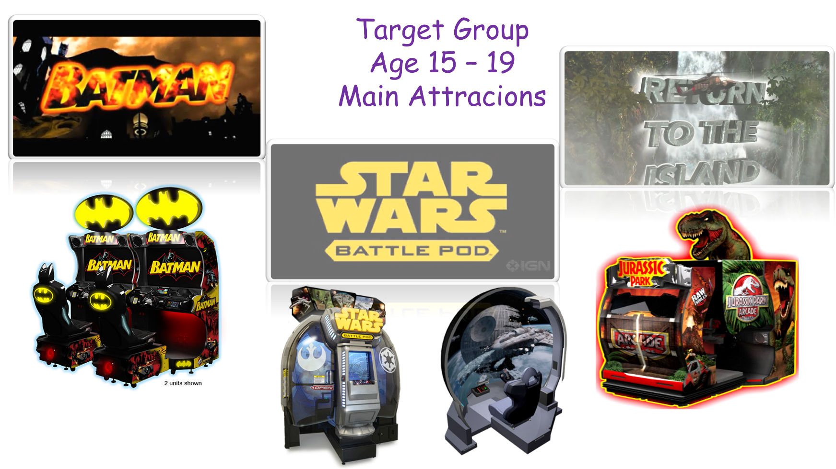
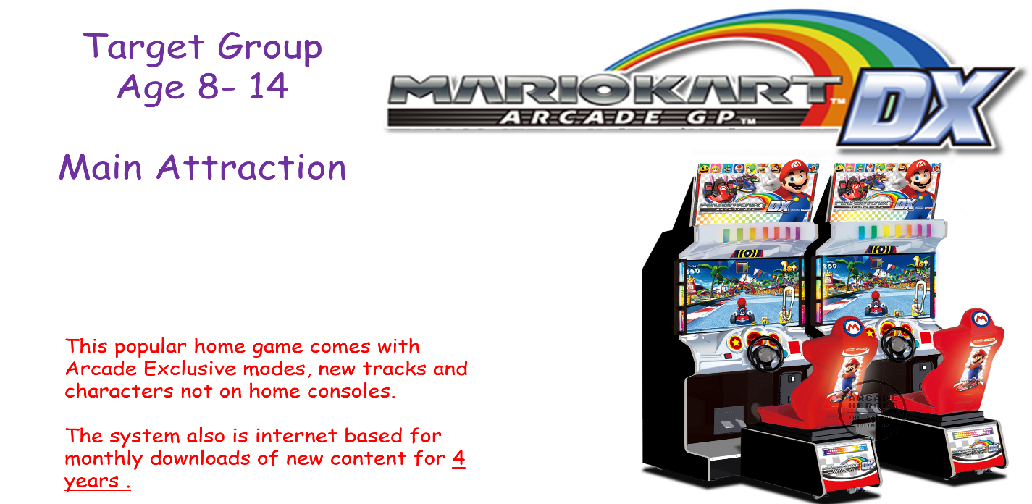

Adult Crowd
Mastering the adult crowd is key to an arcade. Though they only represent 20 % of audience, adults are the most important segment.
Why?
- They are there because of other reasons (the kids, the restaurant and movies) yet they are checking the security of the venue.

- They are the bankers for kids. Keeps their kids close.

- They will determine party/venues in the future.

The Adult Arcade Mix
A three prong approach to adult games will be employed to cease their attention:

- The ‘If you can’t beat them, join them.’ Approach:

Adults love apps on their phones and tablets. Hence super-size their favorite games and bring the top mobile apps to the arcade
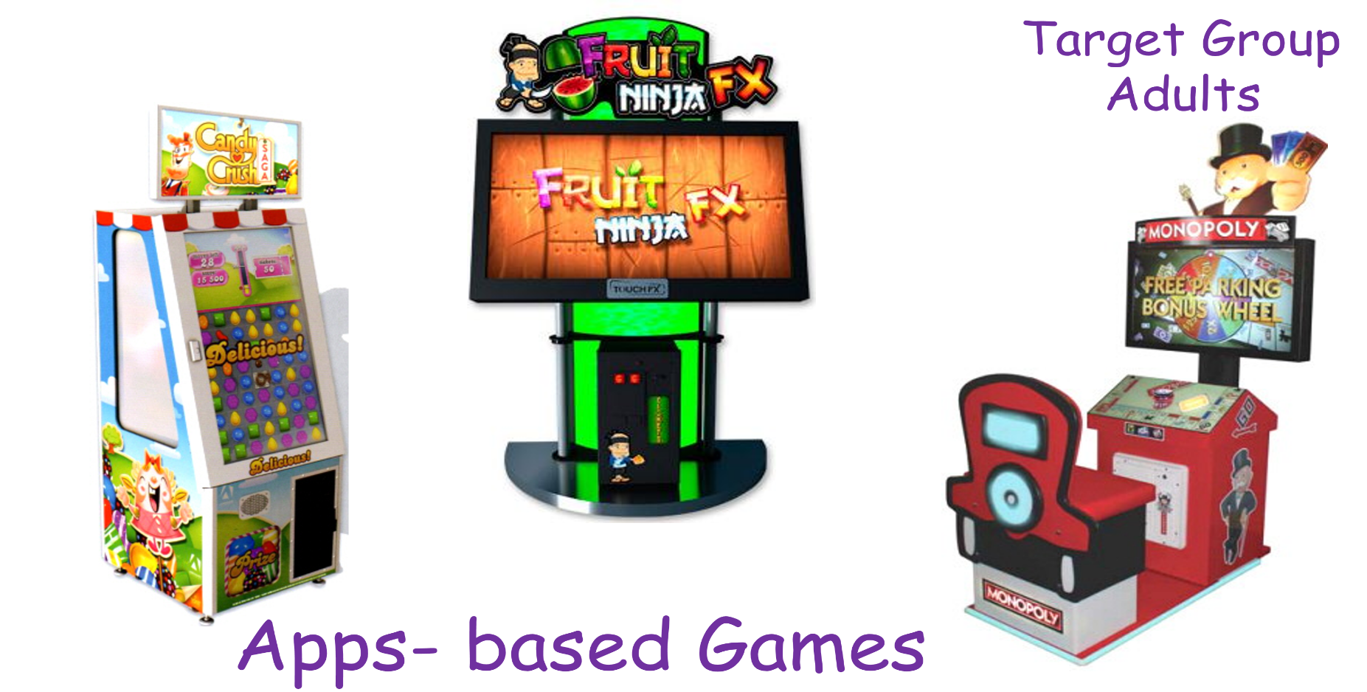
Why would someone come to an arcade to play a game they can download for free and play at home?
The answer is simple.
Patron get to win a PRIZE for playing something they love.
How has it been received?

Let’s look at the #1 downloaded game on the IPAD for 2013 and 2014:

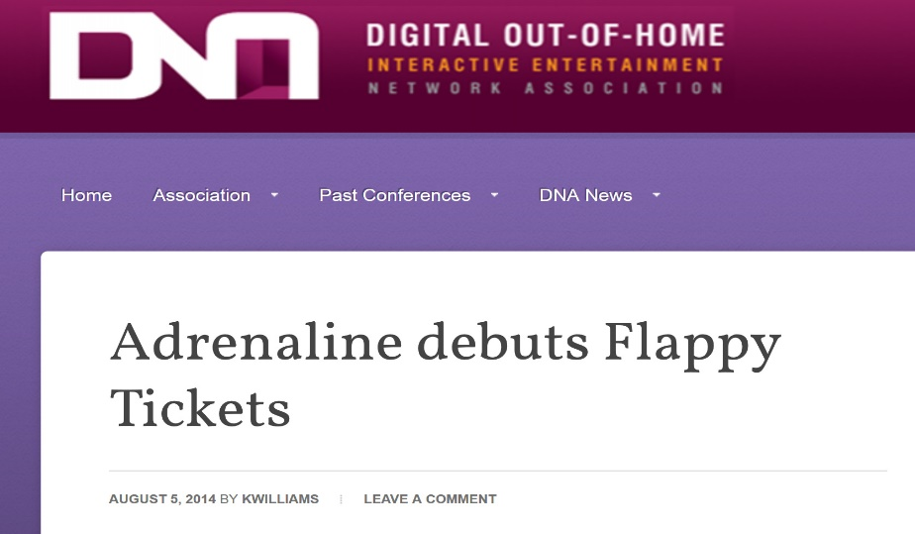
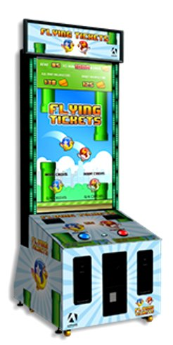
Flappy Birds was brought to arcades in August 2014 with a few modification.
The developer added a two player mode and displayed int on a massive 65 inch screen. Finally arcades gave it a 1000 ticket jackpot feature.
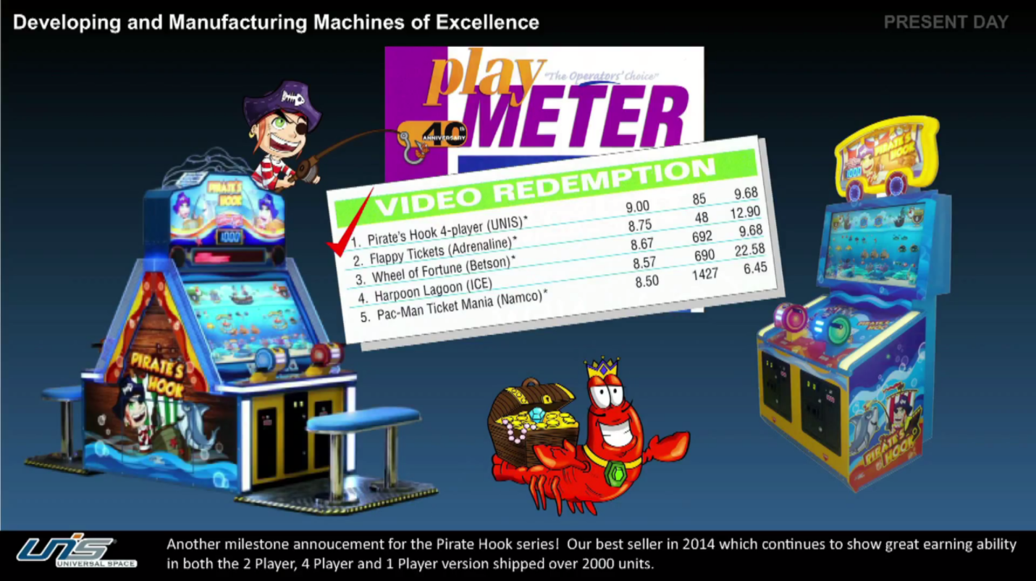
How did people react? The game became a global phenomenon.

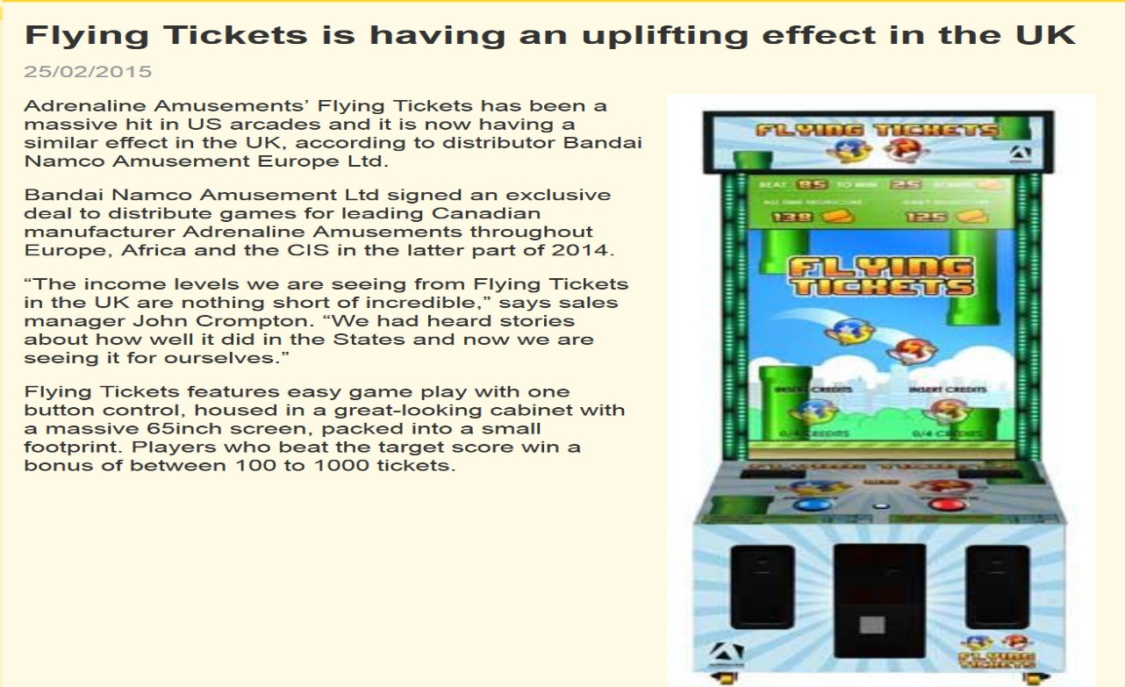
Even though it was only in the market for afew months Flappy Bird (Flying Tickets) was the second highest arcade redemption game.

The Second strategy for Adults
B. Know your people.
Each year when the Carnival arrives at Christmas, thousands of Bahamians descend upon it.
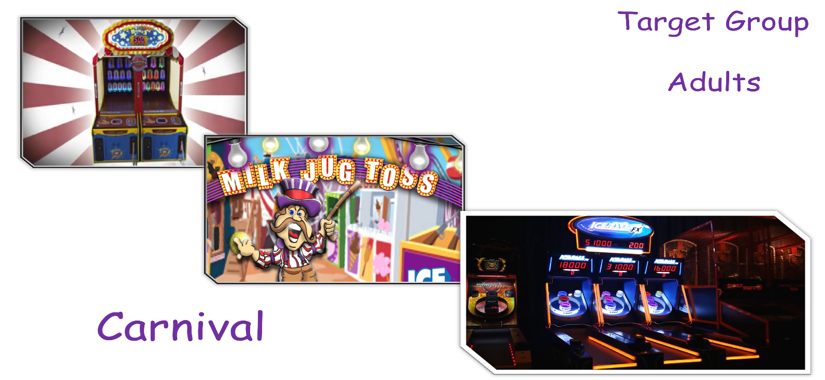
Why? Carnival games are fun. Bahamians love prizes. Give Bahamians what they want.
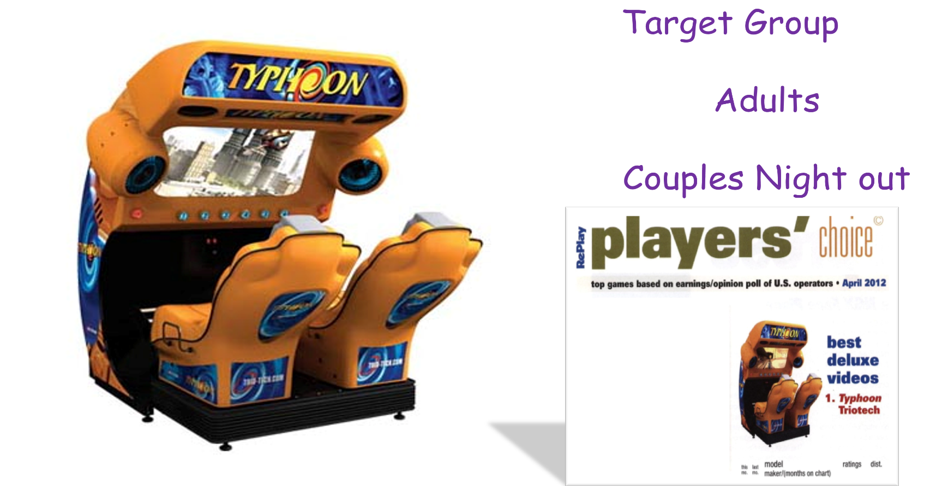
C. Two player fun for Date night.
For young couples, the arcade will offer them something to do until the next movie starts. Introducing Typhoon the #1 simulator in the world.

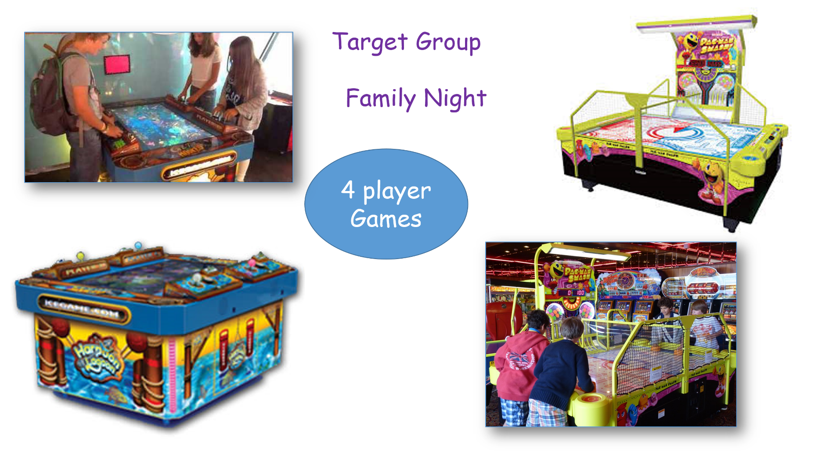
The final group that will be catered to is the entire family:

For the first time in the Bahamas up to four plays will be able to have fun together.

The Arcade Mix is about maximizing profitability will minimizing the risk associated with a bad experience. The Showcase with IMAX may be the main attraction but the arcade will generate revenue for years to come.

